
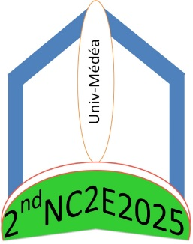
The 2nd National Seminar of Civil Engineering & Environment’2025 (2ndNSC2E2025)
Médéa − 20 February 2025
PARTICIPATION FORM
(to be completed and returned by email before January 5 2025)
2nsc2e25@univ-medea.dz

Name & Forname : …………………………………………………………………………………………………………………
Fonction : ……………………………………………………………………………………………………………………………….
Organization: ………………………………………………………………………………………………………………………
Address: .....................................................................................................................................
City : ………………………………………………………………………………………………………………………………………
Tel / Fax: …………………………………………………………………………………………………………………………………
E-mail : ……………………………………………………………………………………………………………………………………
Theme :
- Building Materials
- Structure Engineering
- Sol & foundation
Title of the communication :
………………………………………………………………………………………………………………………………………………..
………………………………………………………………………………………………………………………………………………..
Presentation preference:
Oral communication
Communication displayed (Poster)

