TITLE XXXXXXXXXXXXXXXXXXXX
MohamedMohamed¹, Mohamed Mohamed²(G, Times, taille 11)

¹Laboratory of XXXXXXX, Ouzera University Campus. 26019, Medea (N, Times, taille 10)
²Laboratory XXXXXXXXXXX, Ouzera University Campus. 26019, Medea (N, Times, taille 10)

Abstract
The abstract must contain the essential resultswith a maximum of 300 words
(italic, Times New Roman, size 11)
Keywords: Keywords are limited to a maximum of 6.

- INTRODUCTION
In order to ensure a good presentation of the collected papers thatwillbeprovided to the participants at the opening of the conference, itis essential to follow the presentation guidelines outlinedbelow.

- MATERIALAND METHODS
The full text of your communication should not exceedeight (08) pages, in Word format using the Times New Roman font, size 11 points, and the definedformat:
Leftmargin: 2.5 cm
Right margin: 2.5 cm
Top margin: 2.5 cm
Bottom margin: 2.5 cm
Start a paragraph 0.5 cm from the marginedge
Single spacing

  - Experimentalprogram
The first letterisuppercase, the restlowercase.
Figures et Tables
Figures and tables are centered. They are numbered in sequentialorder. The legends of the figures as well as the contents and legends of the tables are in lowercasecharactersusing the Times New Roman font, size 11. In the case of tables or figures withcolors, itisrecommended to use contrastingcolors to improve the readability of the figures on the computer screen and on paper.

Table 1 : Table title

- RESULTS
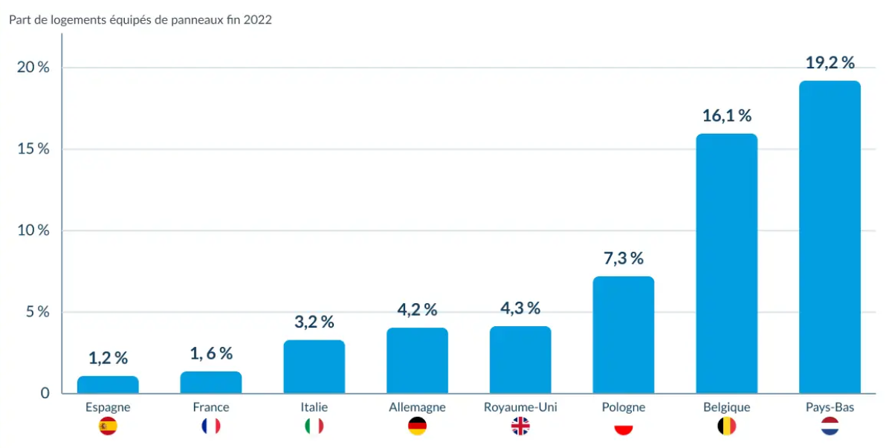
Figure1: The integration of solar panels in Europeanhousing

- DISCUSSION AND CONCLUSION
Wehopewe are not beingtoodemanding by offeringthisworkingtemplate, but itis the onlyway to proceed to ensure a uniformpresentation of the work. Werely on your participation and look forward to meeting you in Medea in June 2025.

- REFERENCES
In the text :
(Hassan et al., 2020).

In the referencelist:
In alphabeticalorder by the last name of the primaryauthor in lowercaseletters, using the Times New Roman font, size 10, without line spacing, according to the followingmodel:

Hassan.H, Yousef. M.S, Ahmed. M.S and Fathy.M, (2020)”Energy, exergy, environnement, and economicanalysis of natural and forcedcooling of solarstillwithporous media,” Environmental Science and Pollution Research . Vol27, N°30, 1-20

